80th Australian Jazz Convention 2026
Picture | Description | Size Ordering | QTY | Total $
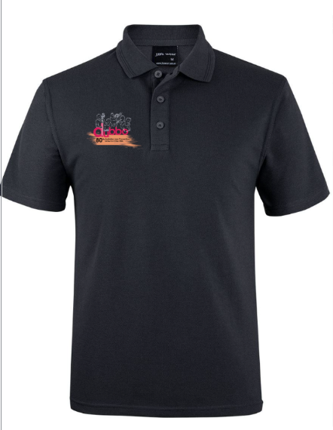 | Polo with embroidered decoration  Black  $50.00 each
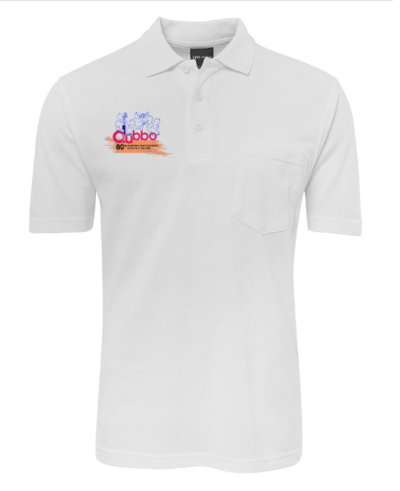 | Polo with embroidered decoration  White  $50.00 each
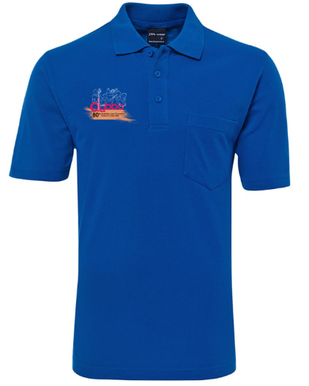 | Polo with embroidered decoration  Royal  $50.00 each
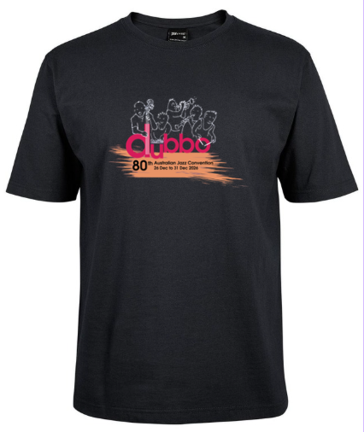 | Tee shirt with printed decoration  Black  $25.00 each | SIZE | QTY | PRICE
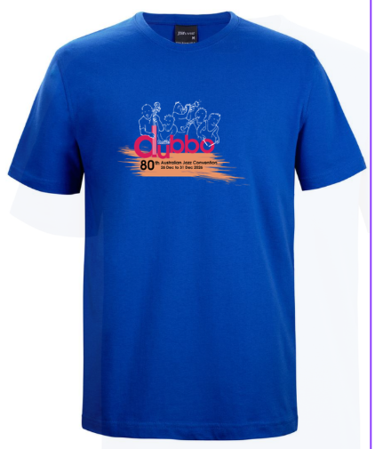 | Tee shirt with printed decoration  Royal  $25.00 each
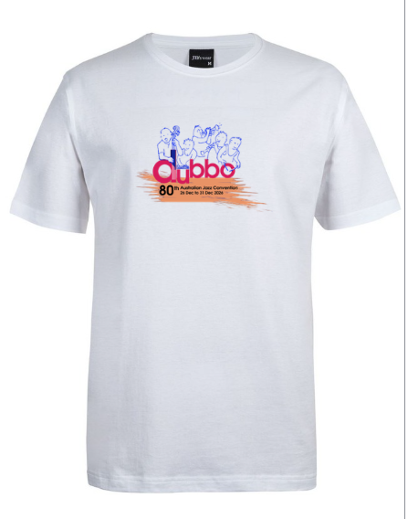 | Tee shirt with printed decoration  White  $25.00 each
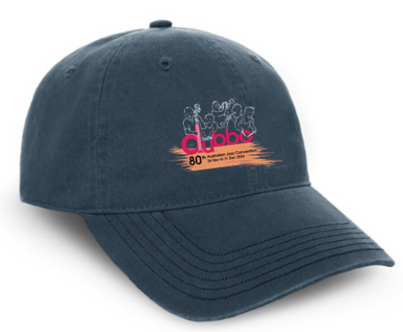 | Cap with embroidered decoration  Navy  $30.00 each |  | QTY | PRICE

TOTAL COST OF ORDER: $________________
Size Guide available for Polos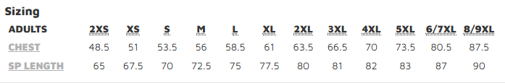
Size guide available for tee shirts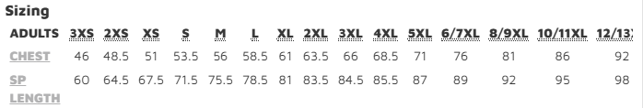

Name:___________________________________________________________
Phone number:___________________________________________________
Email:____________________________________________________________
Payments to: BSB: 063529
Account: 10375556
Account Name: AJC Executive Task Force Incorporated
Reference: <your name>

Please email completed form to: roslyn.pritchard@australianjazzconvention.org.au

